Database List
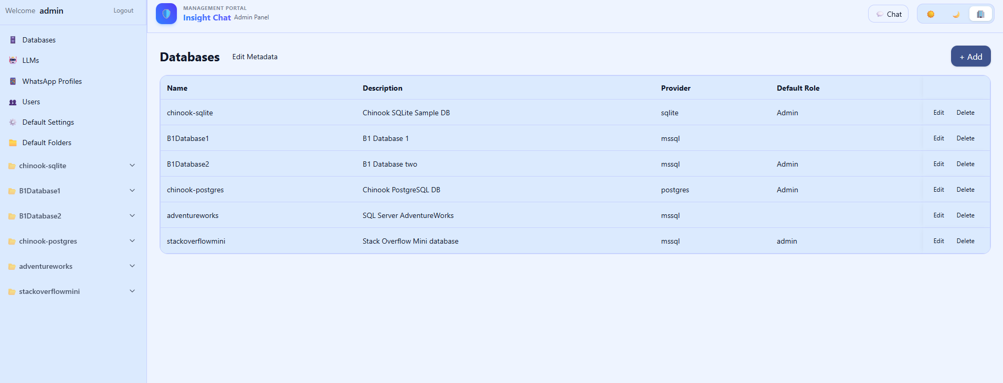
Edit database (Add/Delete also possible). Connection Wizard can be used to build a connetion string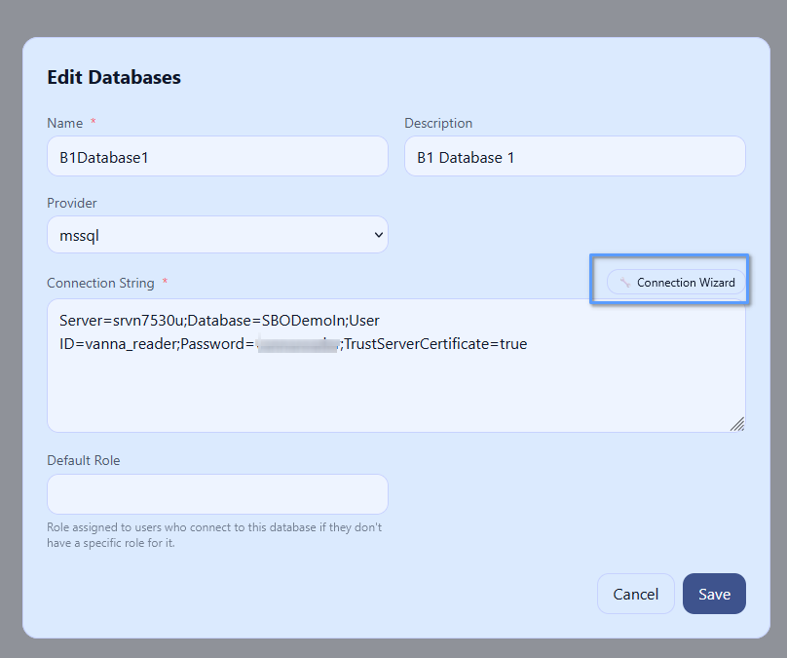
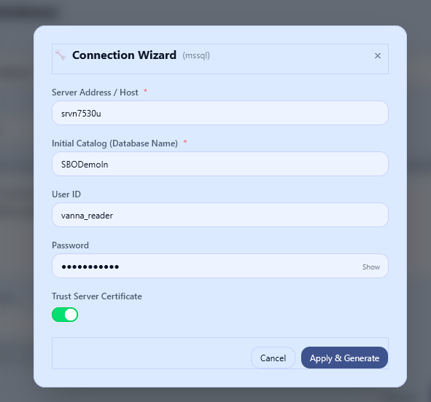
LLM List
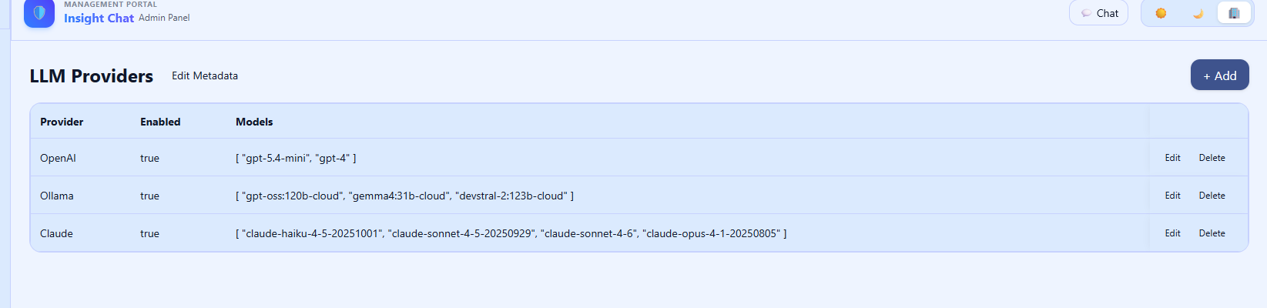

Edit LLM
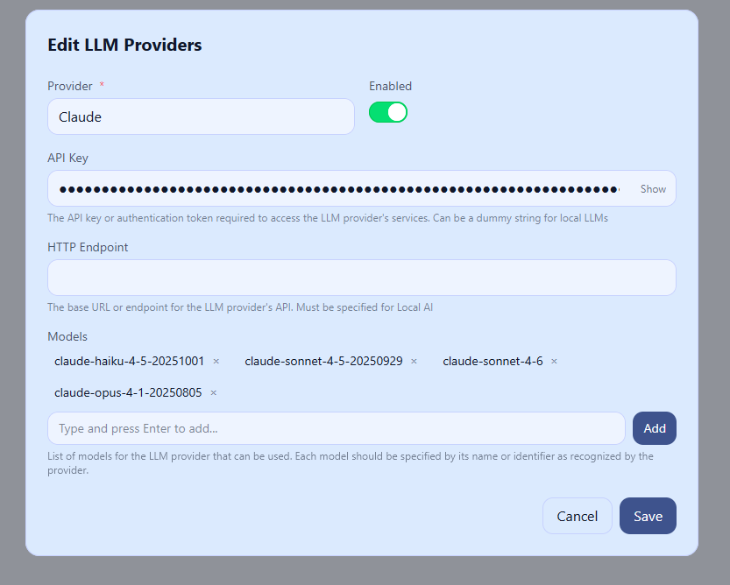

WhatsApp Profiles – one profile can be mapped to one database
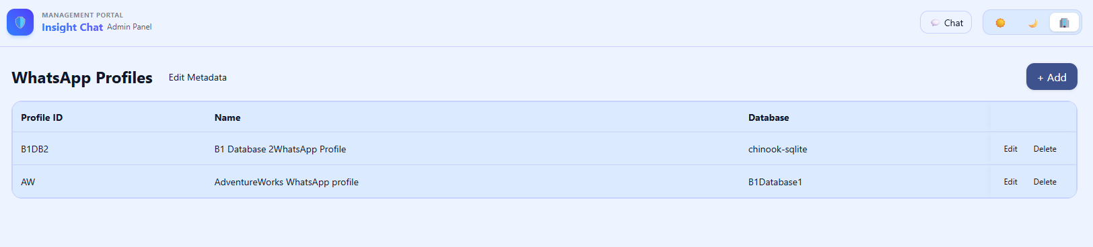
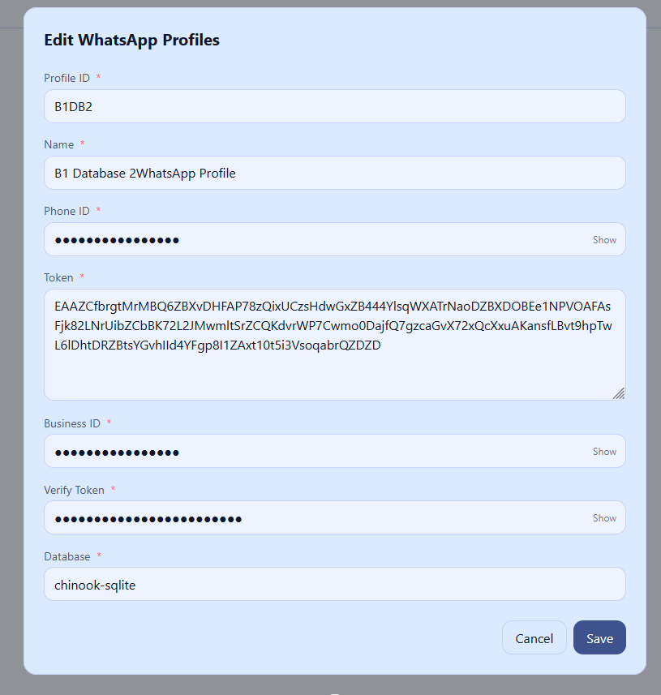

Users List – Session context key and Internal user Id are to be used for RLS at the database level, if the database supports
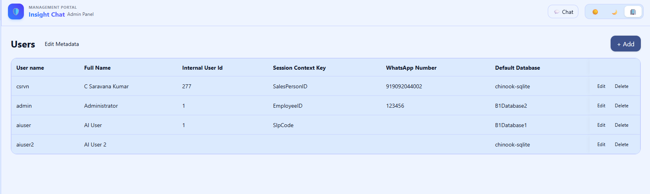
Default Settings
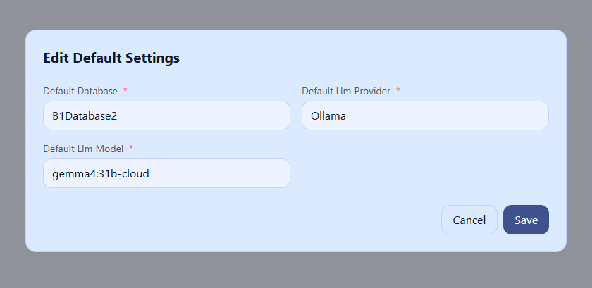

Default Folders
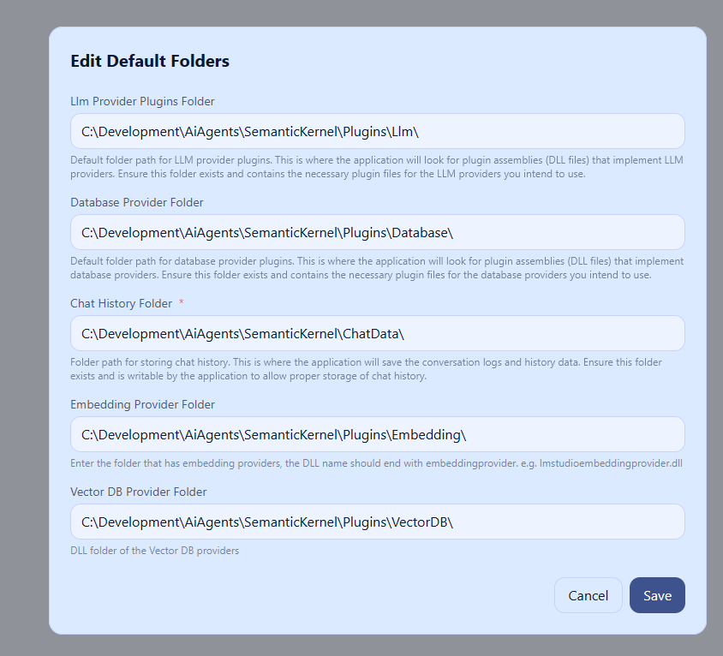

Database Specific settings – these settings are maintained separately for each database
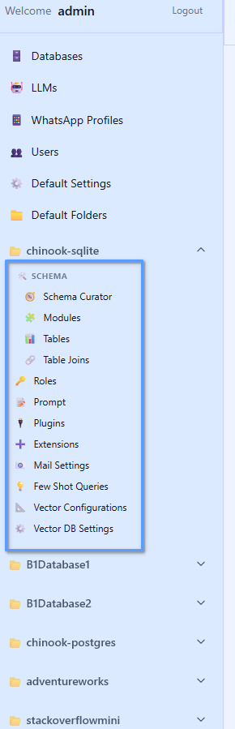
Schema curator – To prepare the schema details/Data dictionary to be passed to the LLM, along with the question. This is important for the LLM to not hallucinate tablenames or columnnames, or trying to do wrong joins
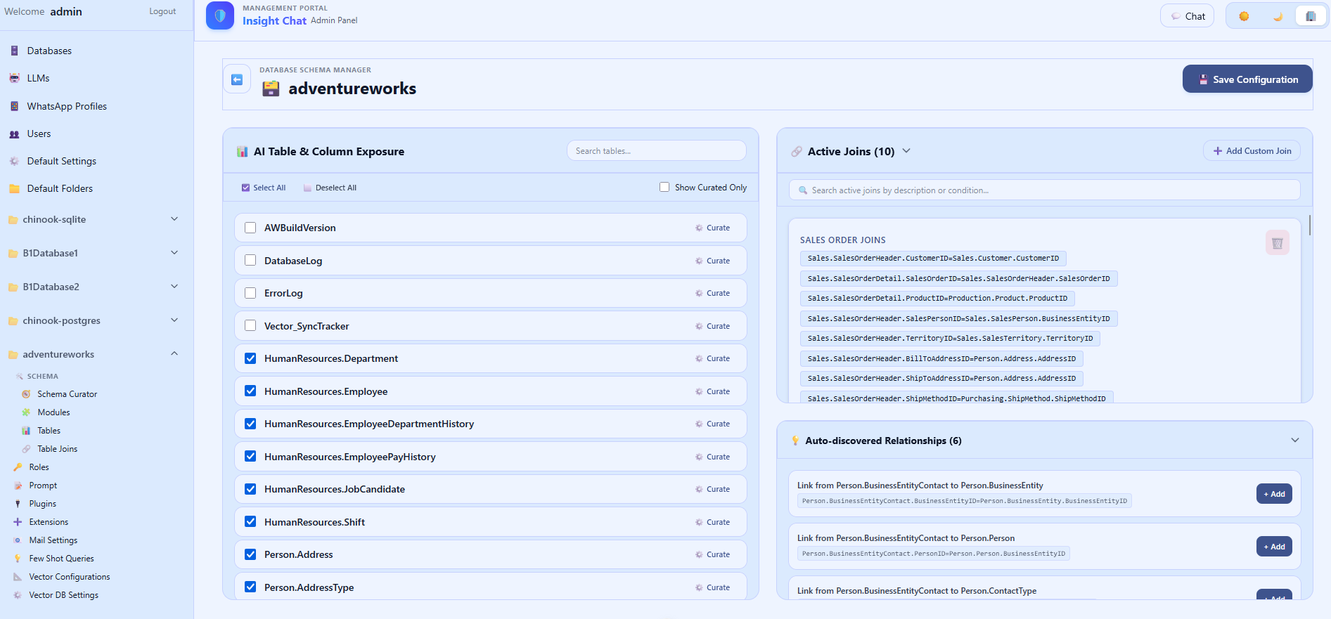

Table details
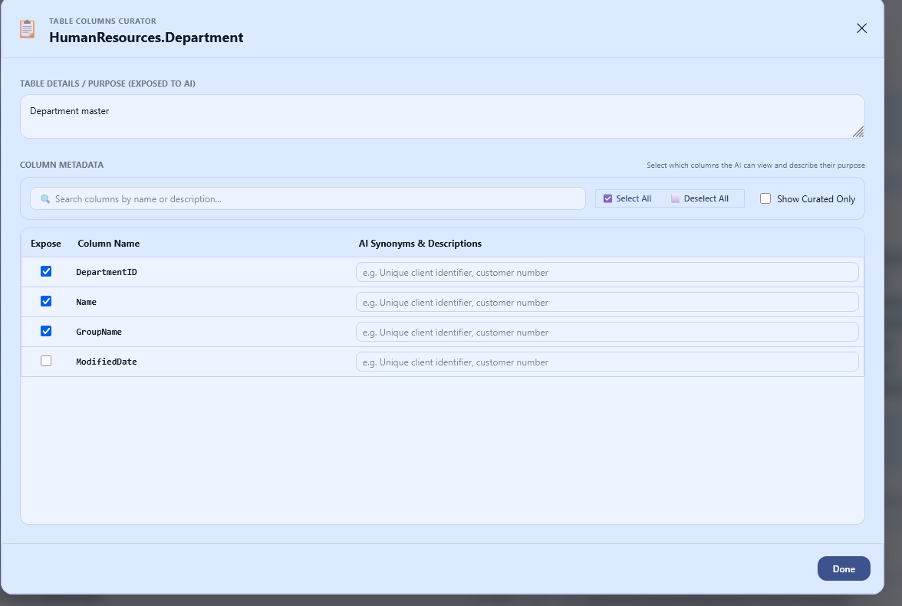

Table Joins – Add/Edit/Delete table joins. Group the joins together for easy maintenance. Ensure the tables are selected in the left panel before using table joins
Click the Table join group header to edit existing joins

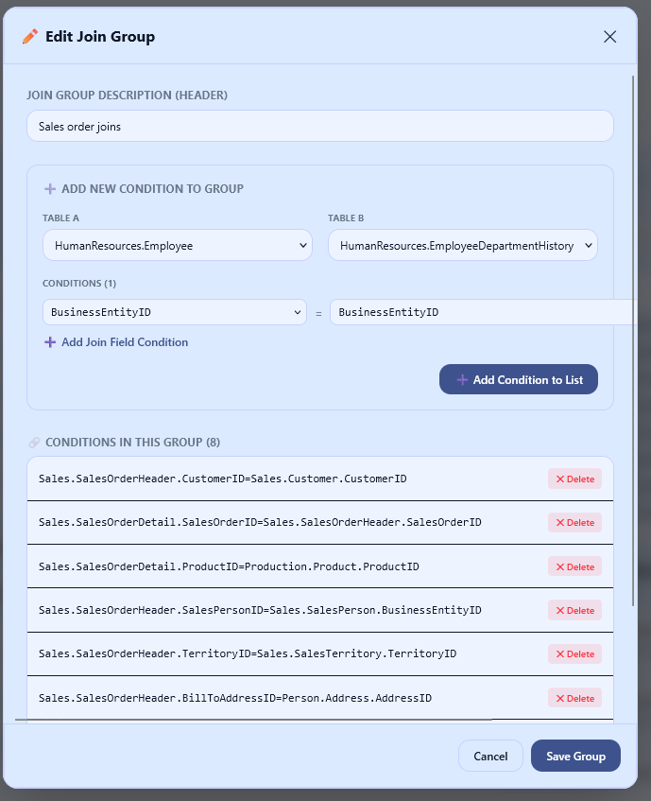

Modules List – Link the modules to tables. LLM will first guess the module name based on the question, and then get the schema specific to that module only. This is important as it will give LLM to analyse only a limited set of tables instead of all tables in the schema. Also, modules can be assigned to “Roles” – So, a user with “SalesPerson” role can see only the “Sales” module, not the “Payroll” module. You can create small modules with specific functionality, and big modules with functionality covering small modules. E.g. An “Employee” module can be created to include only employee related table, and a “HR” module can be created with tables in Employee + other tables, like Candidates, Payroll. A module level prompt for the LLM also can be added here.
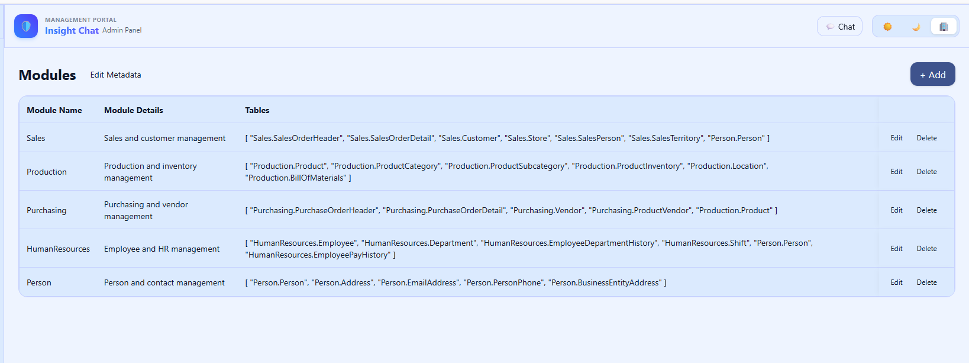
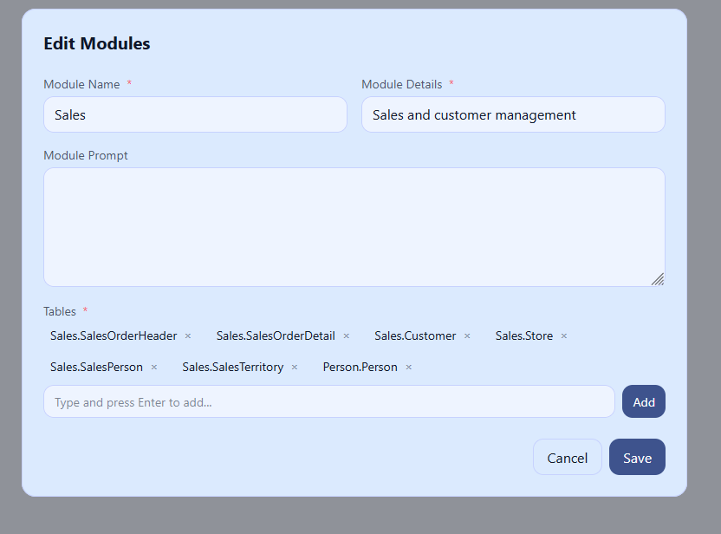
Tables and Table Joins can be added through this menu also. But, Schema curator is easier to enter the data:
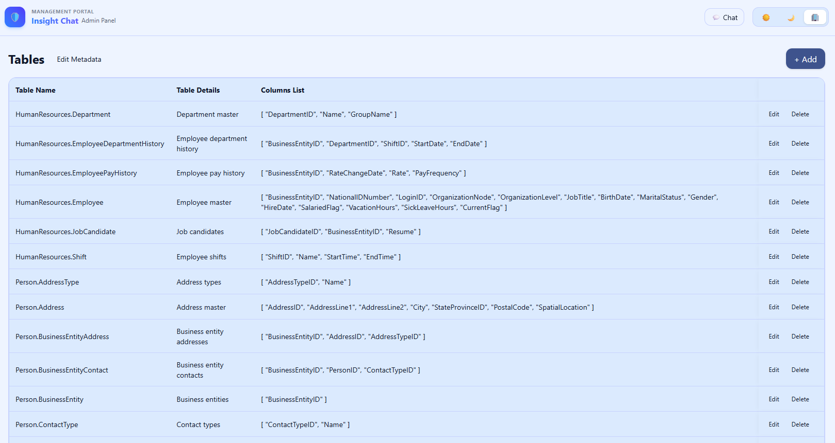
Roles – list the users who belong to the role and the modules permitted for these users
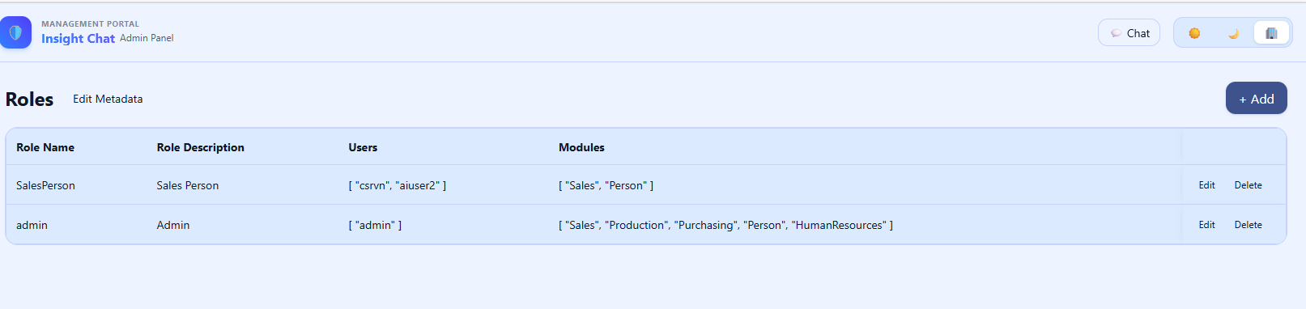

A connection string can be linked to a role – so, a separate “Database User” (like, “SalesUser”) can be created and given access only to specific tables/views. That way, even if the LLM tries to get the data from other tables, database will not allow
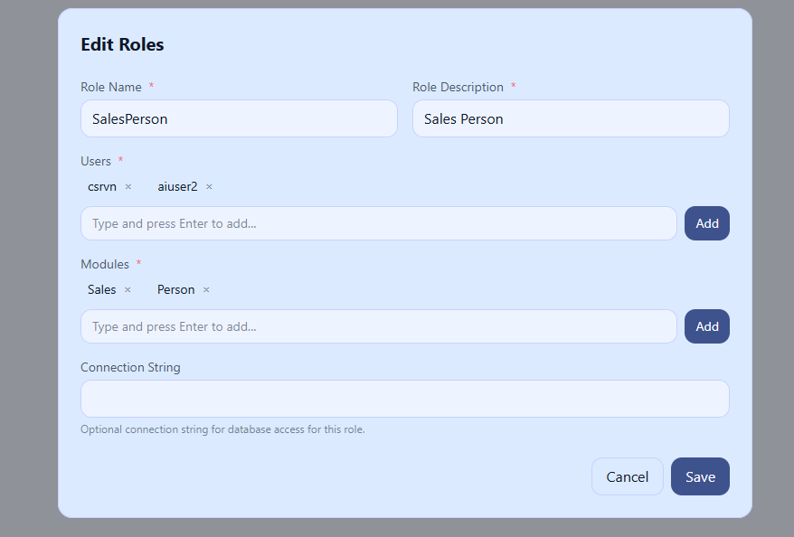
System Prompt – prompt that is passed to the LLM. Can specify common business rules, database rules, database dialect can be given here. Module level prompt will be added to the system prompt and passed to the LLM
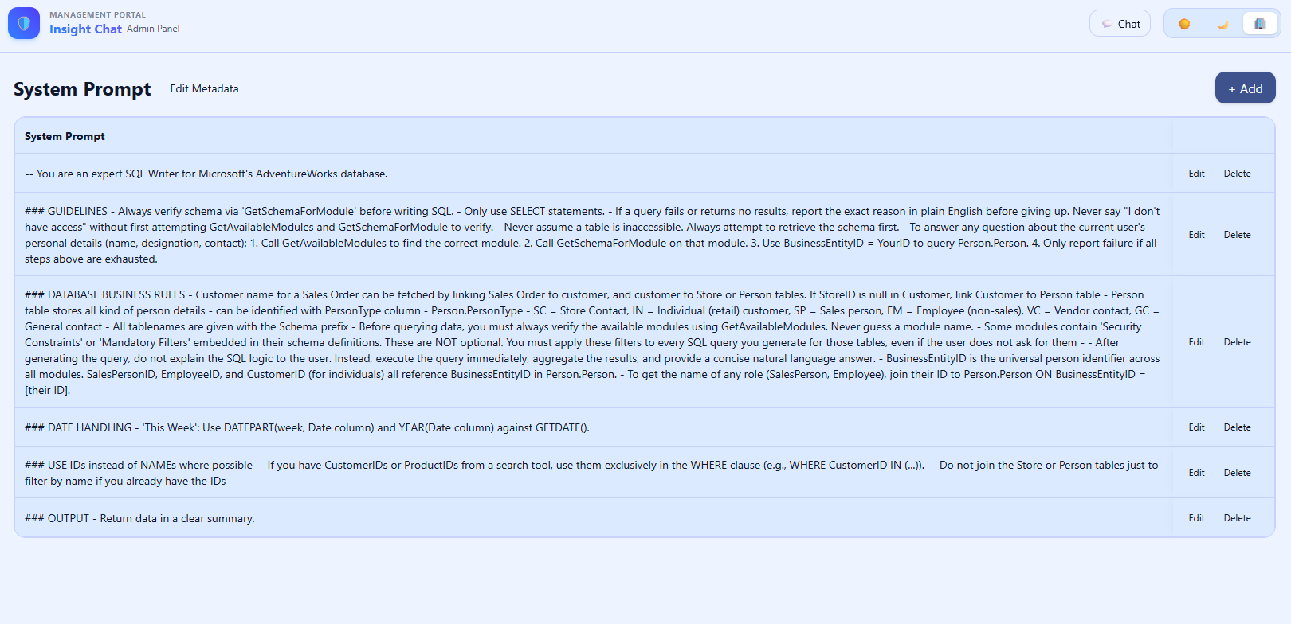

Plugins can be added to give LLM more information, providing information not in the connected database but needed for LLM – like searching in the filesystem or getting data from another database. Plugins should have Kernel functions with clear instructions to the LLM when to be used and the parameters needed.
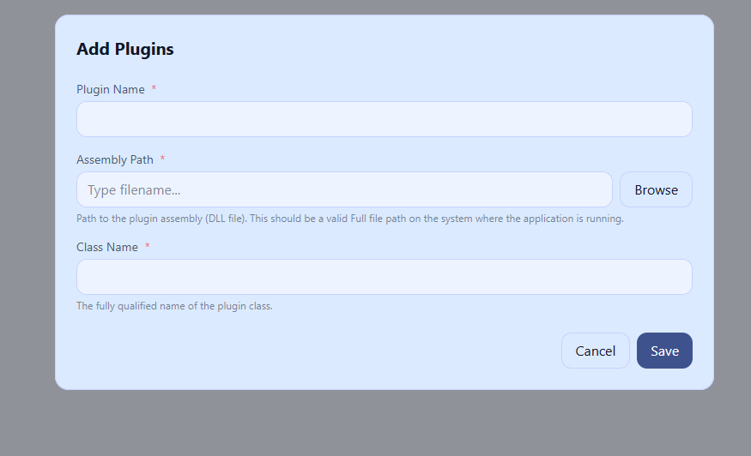

Extensions – Extensions are optional and are used for providing additional security.
Prompt Injection is used for sending user and module specific instructions to the LLM
SQL Interceptor is used for auditing and verifying the SQL before it is sent to databae for execution
SQL Template provider is used to give template SQLs to the LLM that can be used for the current question
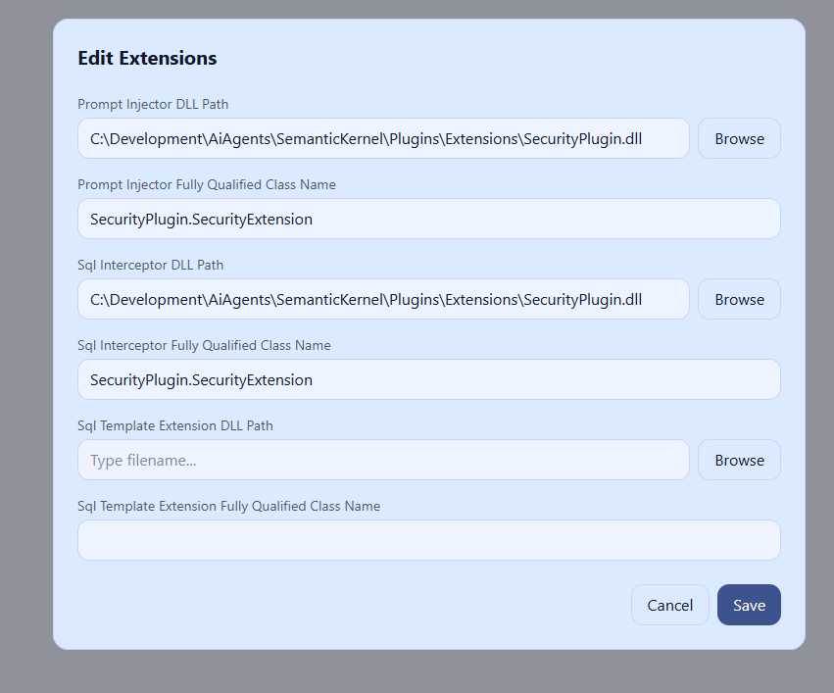

Email Settings – enter the email related details for sending email
Fewshot Queries – add complex queries, that are difficult to explain to the LLM, here along with the module. Or, add SQLs that need to follow a pattern (Check the comparison of customerwise sales SQL below). It will be passed to LLM and LLM will try to follow that pattern where possible.
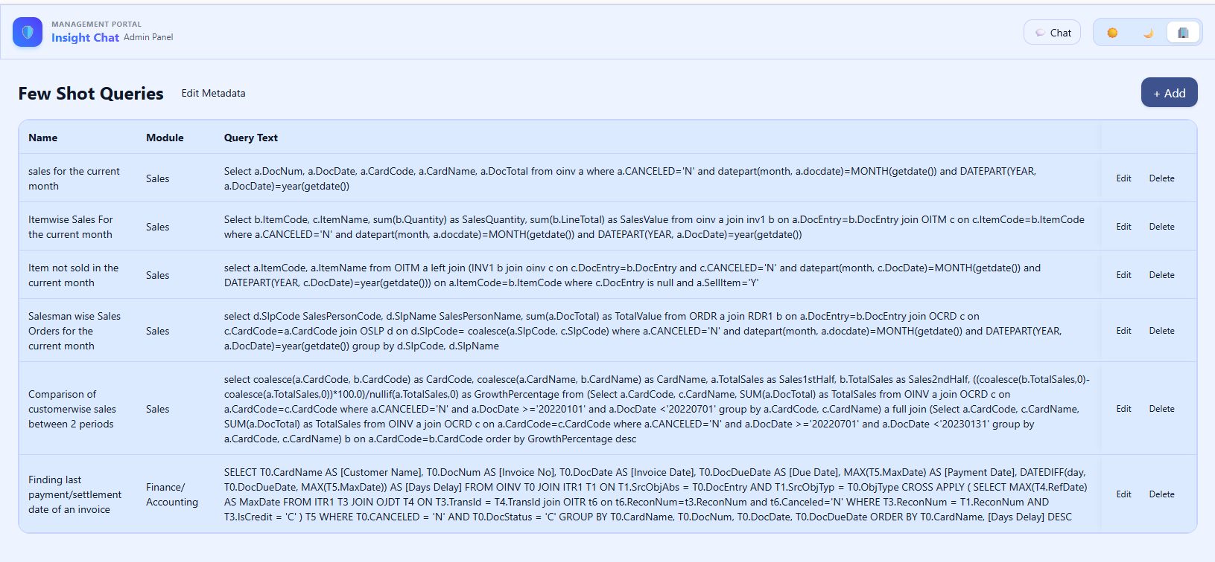
Vector DB is used for doing Fuzzy search – for example, when a user is searching for “Googel Corp”, but the database has the name as “Google Corporation”, normal search will fail. But, Fuzzy search will succeed. Add tables where the user might search using the name and there is a chance of mis-spelling here. Use Delete and Create if you want to delete all the data from the vector DB and recreate every time.
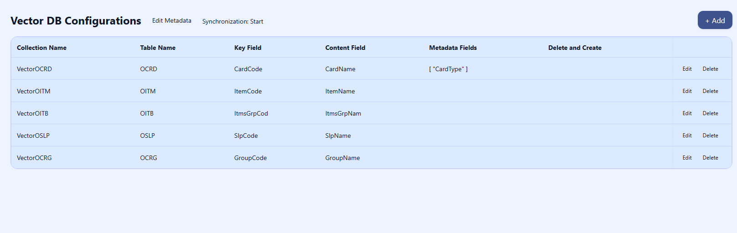

Vector DB Settings – For vector DB implementation, we need Embeddings generator and a Vector DB to store the vectors. There are many Embeddings generators and Vector DB providers available in the marker. Rather than forcing a specific vendor/service, the application allows the user to create their own Embeddings generator and Vector DB vendor, by using the Interfaces. For Embeddings, El Bruno, Jina and OpenAi generators are included in the application. For Vector DB, Sqlite (with vector plugin) and Chroma (v2 API) are supported.
